Table of Contents
1. Introduction
2. Dataset Description
3. Problem Formulation
4. Exploratory Data Analysis
5. Data Preprocessing
6. Feature Engineering
7. Model Development
8. Class Imbalance Handling
9. Model Evaluation and Results
10. Explainable AI
11. Cybersecurity Interpretation
12. Conclusion
13. AI Disclosure

Ransomware Detection and Risk Modeling in Healthcare
1. Introduction
Ransomware has become one of the most damaging cybersecurity threats faced by healthcare organizations. Hospitals, clinics, pharmaceutical companies, health insurance firms, and research laboratories depend on digital systems for patient records, diagnosis, scheduling, billing, research data, and daily operational continuity. When ransomware encrypts or steals sensitive healthcare data, the effect is not only financial but can also interrupt patient care and weaken trust in healthcare services.
The healthcare sector is especially vulnerable because it stores sensitive personal and medical information and often operates with critical time constraints. Attackers may use phishing emails, compromised credentials, remote desktop protocol exploits, malicious websites, infected removable media, or software vulnerabilities to gain access. Once inside a network, ransomware can encrypt data, compromise backups, affect several facilities, and create pressure to pay ransom.
The objective of this report is to design and evaluate advanced machine learning models for ransomware detection and risk modeling in healthcare. The analysis uses the Healthcare Ransomware Dataset and applies supervised classification, anomaly detection, class imbalance handling, and explainable artificial intelligence. The main focus is to predict ransomware-related outcomes and interpret which cybersecurity features influence these predictions.
This report follows the assignment requirements by formulating two machine learning problems, performing exploratory data analysis, developing engineered features, training at least five models, comparing imbalance handling techniques, evaluating models using standard classification metrics, and applying explainable AI methods.
2. Dataset Description
The dataset used in this project is the Healthcare Ransomware Dataset. It contains 5,000 ransomware-related records and 16 original columns. Each record represents a ransomware incident or simulated healthcare cybersecurity case with organizational, technical, attack-related, and recovery-related attributes.
The dataset contains variables describing the organization type, organization size, number of affected facilities, cybersecurity monitoring frequency, backup compromise status, ransomware infection rate, whether data was encrypted or stolen, recovery time, attack entry method, ransom payment status, amount of data restored, and number of ransomware incidents.
No missing values were found in the dataset. However, preprocessing was still included in the machine learning pipeline to ensure robustness. The attack_date field was converted into date-time format and additional date-related variables were extracted. The value Jan-50 in the cyber_threats_tracked column was treated as a formatting issue and replaced with 1-50.

Table 1: Dataset feature description
Feature | Description | Type
id | Unique incident identifier | Identifier
attack_date | Date and time of ransomware attack | Date-time
org_type | Type of healthcare organization | Categorical
org_size | Size of organization | Categorical
facilities_affected | Number of affected facilities | Numerical
cyber_threats_tracked | Threat tracking capacity/range | Categorical
monitoring_freq | Security monitoring frequency | Categorical
backup_compromised | Whether backups were compromised | Boolean
ransomware_infection_rate_(%) | Percentage infection rate | Numerical
data_encrypted | Whether data was encrypted | Boolean/Target
data_stolen | Whether data was stolen | Boolean
recovery_time_(days) | Time required for recovery | Numerical
entry_method | Attack entry method | Categorical
paid_ransom | Whether ransom was paid | Boolean/Target
data_restored | Percentage/amount of data restored | Numerical
ransomware_incidents | Number of ransomware incidents | Numerical
3. Problem Formulation
Two machine learning problems were formulated to satisfy the assignment requirement and to represent important ransomware decision-making tasks in healthcare cybersecurity.
3.1 Problem 1: Ransom Payment Prediction
The first machine learning problem is ransom payment prediction. The target variable is paid_ransom, which indicates whether an organization paid ransom after a ransomware attack. The input features include organization type, organization size, facilities affected, cyber threats tracked, monitoring frequency, backup compromise, ransomware infection rate, data encryption, data theft, recovery time, entry method, data restored, ransomware incidents, and engineered risk features.
This problem is important because predicting ransom payment can help cybersecurity teams understand which attack conditions create financial and operational pressure. If a model identifies high-risk cases where ransom payment is likely, decision-makers can improve backup protection, incident response plans, negotiation policies, and recovery readiness before such attacks occur.
3.2 Problem 2: Attack Success Prediction
The second machine learning problem is attacking success prediction. The target variable is data_encrypted, which indicates whether the ransomware attack successfully encrypted organizational data. The input features include organizational characteristics, attack entry method, infection rate, backup compromise, data theft, recovery time, monitoring frequency, and engineered severity indicators.
This problem is important because data encryption is a major indicator of ransomware success. Predicting encryption risk can help healthcare organizations identify weaknesses that allow ransomware to cause operational disruption. This information can guide prevention strategies such as stronger access control, vulnerability patching, phishing defense, backup segmentation, and real-time monitoring.
Table 2. Machine learning problem formulation
ML Problem | Target Variable | Input Features | Cybersecurity Importance
Ransom payment prediction | paid_ransom | Organizational, attack, recovery, and engineered risk features | Identifies conditions that increase pressure to pay ransom
Attack success prediction | data_encrypted | Organizational, attack, backup, and severity features | Identifies factors associated with successful ransomware encryption
4. Exploratory Data Analysis
Exploratory data analysis was performed to understand the dataset structure, class distribution, numerical distributions, categorical patterns, missing values, outliers, and feature relationships. EDA is an important step because it reveals data quality issues and helps select suitable preprocessing and modeling methods.
4.1 Dataset Shape and Summary
The dataset contains 5,000 records and 16 original variables. There were no missing values in the dataset. The id column is a unique identifier and was removed from model training because it does not carry predictive cybersecurity meaning. The attack_date column was converted into date-time format and then used to create attack month, attack day of week, and attack hour features.
4.2 Class Distribution and Imbalance
Class distribution was analyzed for the two selected target variables. For paid_ransom, the dataset is almost balanced, with 2,532 False cases and 2,468 True cases. For data_encrypted, the dataset is imbalanced, with 4,241 True cases and 759 False cases. This means that attack success prediction has a stronger imbalance problem than ransom payment prediction.
Table 3. Class distribution of target variables
Target Variable | Class | Count | Percentage
paid_ransom | False | 2532 | 50.64%
paid_ransom | True | 2468 | 49.36%
data_encrypted | True | 4241 | 84.82%
data_encrypted | False | 759 | 15.18%

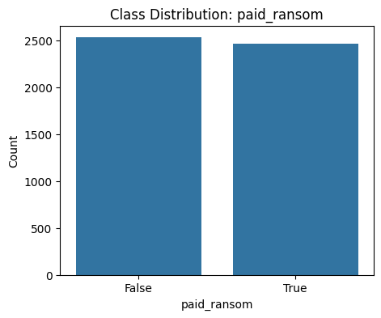
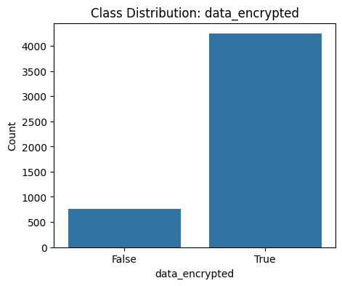
Figure 1. Class distribution
4.3 Numerical Feature Distributions
The numerical variables include facilities affected, ransomware infection rate, recovery time, data restored, and ransomware incidents. The average number of affected facilities is approximately 12.76, with values ranging from 1 to 24. The average ransomware infection rate is about 56.31%, with a maximum value of 90%. The average recovery time is about 43.76 days, with a maximum of 120 days. These variables are important because they directly reflect the operational impact and recovery burden caused by ransomware.
4.4 Categorical Feature Distributions
Categorical variables were examined to identify common organizational and attack patterns. Hospitals are the most frequent organization type in the dataset, followed by clinics, insurance organizations, pharmaceutical organizations, and research laboratories. The most common organization size is medium. For attack entry methods, compromised credentials and exploited vulnerabilities appear most frequently, followed by phishing email and RDP exploit. These findings are consistent with common ransomware attack paths where weak credentials, unpatched systems, and phishing remain major cybersecurity risks.
4.5 Correlation and Initial Feature Relationships
Correlation analysis was used to inspect relationships among numerical variables and Boolean variables converted to numeric form. Although correlation does not prove causation, it helps identify variables that may be related to ransomware outcomes. For example, recovery time, infection rate, affected facilities, backup compromise, data theft, and attack severity indicators are expected to show meaningful relationships with ransom payment or encryption outcomes.
5. Data Preprocessing
Data preprocessing was necessary to prepare the dataset for machine learning. Although the dataset did not contain missing values, imputation was included in the preprocessing pipeline to make the workflow robust if future data contain missing entries.
Numerical variables were imputed using the median strategy and standardized using StandardScaler. Scaling is important for algorithms such as Logistic Regression and Neural Network because these models are sensitive to feature magnitude. Categorical variables were imputed using the most frequent category and encoded using one-hot encoding. This converted text-based categories into numerical variables that machine learning algorithms can process.
Outliers were checked using boxplots. The Interquartile Range method was used to clip extreme values in numerical features. Outlier handling is important because extreme recovery times or infection rates may overly influence some models and reduce generalization performance.
The id column was removed from modeling because it is a unique identifier. The attack_date column was transformed into attack_month, attack_dayofweek, and attack_hour so that temporal attack patterns could be used as predictive features.
6. Feature Engineering
Feature engineering was performed to convert raw ransomware variables into meaningful cybersecurity indicators. The assignment required at least three engineered features, and three main engineered features were created: risk score, recovery efficiency ratio, and attack severity index.
Table 4. Engineered feature description
Engineered Feature | Formula / Logic | Cybersecurity Meaning
Risk Score | Weighted combination of infection rate, affected facilities, backup compromise, data theft, and incidents | Represents overall ransomware risk and organizational exposure
Recovery Efficiency Ratio | data_restored / (recovery_time_days + 1) | Measures how efficiently an organization restores data after attack
Attack Severity Index | Infection rate + recovery time + facilities affected + encryption + data theft | Represents overall seriousness and operational impact of attack
Attack Month/Day/Hour | Extracted from attack_date | Captures possible temporal patterns in attacks
6.1 Risk Score
The risk score combines several ransomware indicators into one composite feature. A higher score means the organization experienced a more risky ransomware situation, such as high infection rate, more affected facilities, compromised backup, stolen data, and repeated ransomware incidents. This feature is meaningful because ransomware risk is usually not caused by one factor only; it results from multiple combined technical and operational weaknesses.
6.2 Recovery Efficiency Ratio
The recovery efficiency ratio measures the amount of data restored relative to recovery time. A higher value suggests better recovery capability and stronger cyber resilience. This feature is important because healthcare organizations with faster and more complete recovery may experience less pressure to pay ransom.
6.3 Attack Severity Index
The attack severity index combines infection rate, recovery time, affected facilities, data encryption, and data theft. It represents the seriousness of the ransomware incident. This feature can improve model performance because it summarizes the operational and security impact of an attack in a single variable.
7. Model Development
Five models were implemented to satisfy the assignment requirement: Logistic Regression, Random Forest, XGBoost, Neural Network, and Isolation Forest. These models were selected because they represent different machine learning approaches, including baseline linear classification, ensemble learning, gradient boosting, neural learning, and unsupervised anomaly detection.
Table 5. Model development summary
Model | Type | Reason for Use
Logistic Regression | Supervised linear classifier | Provides a simple and interpretable baseline
Random Forest | Supervised ensemble classifier | Captures nonlinear feature relationships and provides feature importance
XGBoost | Gradient boosting classifier | Often performs well on structured tabular data
Neural Network | Multi-layer perceptron classifier | Learns complex patterns among features
Isolation Forest | Unsupervised anomaly detection | Detects abnormal or suspicious ransomware patterns
The main supervised modeling target was paid_ransom, while data_encrypted was used as the second machine learning problem. The dataset was split into training and testing sets using stratified sampling to preserve class distribution. The models were evaluated on unseen test data to estimate generalization performance.
8. Class Imbalance Handling
Class imbalance occurs when one class appears much more frequently than another class. In cybersecurity datasets, imbalance is common because high-risk or attack-success events may be rarer than normal or less severe cases. If imbalance is not handled, a model may learn to predict the majority class and ignore the minority class.
The assignment required analysis of class imbalance and application of balancing techniques such as SMOTE, undersampling, and class weighting. Therefore, all supervised models were compared before and after balancing. Isolation Forest was not included in SMOTE or class-weighting comparison because it is an unsupervised anomaly detection model and does not use class labels during training in the same way as supervised classifiers.
Table 5. Class imbalance handling techniques
Balancing Technique | Explanation | Expected Benefit
Original data | Model trained without balancing | Shows baseline performance before imbalance treatment
SMOTE | Creates synthetic minority-class examples | Improves minority-class learning and recall
Random undersampling | Reduces majority-class examples | Reduces majority-class dominance
Class weighting | Assigns higher penalty to minority-class errors | Improves sensitivity to minority class without changing data size
In the report, the comparison should focus mainly on F1-score, recall, and ROC-AUC. F1-score is especially useful for imbalanced cybersecurity problems because it balances precision and recall. Recall is important because missing a serious ransomware case can be costly for healthcare operations.
9. Model Evaluation and Results
The models were evaluated using precision, recall, F1-score, ROC-AUC, and confusion matrix. These metrics provide a complete view of model performance. Accuracy alone is not enough for ransomware modeling because a model can achieve high accuracy by favoring the majority class imbalanced data.
Table 6. Performance comparison before and after balancing
 | Model | Balancing Method | Accuracy | Precision | Recall | F1-score | ROC-AUC
0 | Logistic Regression | Original | 0.870 | 0.850000 | 0.894737 | 0.871795 | 0.910647
1 | Logistic Regression | SMOTE | 0.868 | 0.846743 | 0.894737 | 0.870079 | 0.910743
2 | Logistic Regression | Undersampling | 0.868 | 0.846743 | 0.894737 | 0.870079 | 0.910671
12 | Logistic Regression | Class Weighting | 0.867 | 0.845124 | 0.894737 | 0.869223 | 0.910607
11 | Neural Network | Undersampling | 0.826 | 0.795203 | 0.872470 | 0.832046 | 0.900810
10 | Neural Network | SMOTE | 0.826 | 0.803030 | 0.858300 | 0.829746 | 0.896049
9 | Neural Network | Original | 0.815 | 0.803536 | 0.827935 | 0.815553 | 0.889148
3 | Random Forest | Original | 0.872 | 0.875000 | 0.864372 | 0.869654 | 0.915740
13 | Random Forest | Class Weighting | 0.872 | 0.878099 | 0.860324 | 0.869121 | 0.916232
4 | Random Forest | SMOTE | 0.871 | 0.876289 | 0.860324 | 0.868233 | 0.909695
5 | Random Forest | Undersampling | 0.870 | 0.869919 | 0.866397 | 0.868154 | 0.917304
14 | XGBoost | Class Weighting | 0.879 | 0.894292 | 0.856275 | 0.874871 | 0.920961
7 | XGBoost | SMOTE | 0.879 | 0.895966 | 0.854251 | 0.874611 | 0.925485
8 | XGBoost | Undersampling | 0.879 | 0.895966 | 0.854251 | 0.874611 | 0.922661
6 | XGBoost | Original | 0.878 | 0.899142 | 0.848178 | 0.872917 | 0.921873
The best model should be selected based on F1-score, with ROC-AUC used as supporting evidence. In ransomware detection and risk modeling, F1-score is suitable because both false positives and false negatives matter. A false negative may fail to identify a high-risk ransomware case, while a false positive may waste cybersecurity resources. Therefore, the final model choice should consider both predictive performance and cybersecurity usefulness.
10. Explainable AI
Explainable AI was used to interpret how machine learning models made predictions. This is important in cybersecurity because analysts must understand why a case is predicted as high-risk, not only the final prediction. The assignment required at least one explainability method, such as SHAP, LIME, or feature importance plots.
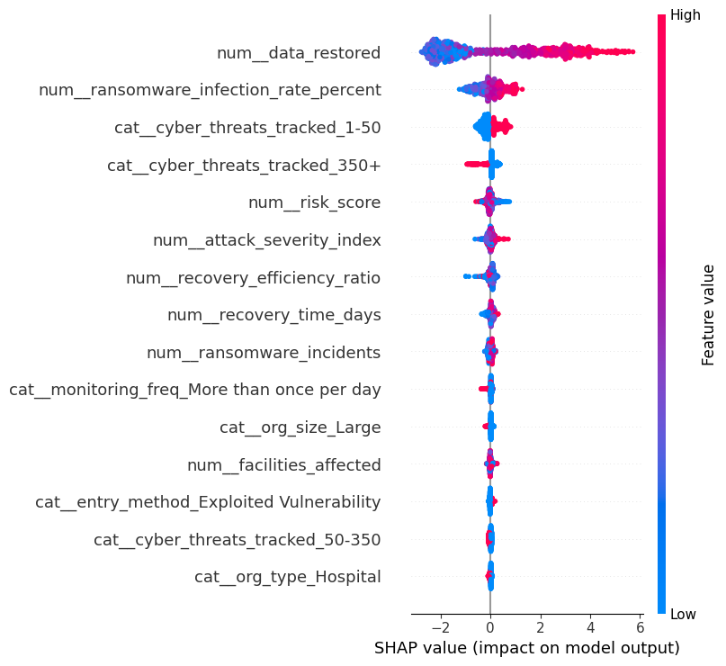
Figure 2. SHAP-Based Feature Importance for Ransom Payment Prediction
Feature importance was applied using Random Forest because this model provides direct importance scores for input variables. SHAP can also be used with XGBoost or Random Forest to explain how features increase or decrease prediction probability. LIME can explain one individual prediction by showing which features pushed the model toward ransom payment or no ransom payment.
The expected important features include risk score, attack severity index, recovery time, ransomware infection rate, backup compromise, data theft, data encryption, affected facilities, and ransomware incidents. These features align with cybersecurity intuition because they directly represent damage, operational disruption, exposure level, and recovery pressure. If backup is compromised or recovery time is long, an organization may be more likely to face pressure to pay ransom. If infection rate and affected facilities are high, the attack is more severe and may create stronger business disruption.
11. Cybersecurity Interpretation
The machine learning results should be interpreted from a cybersecurity perspective. The purpose of the models is not only to obtain high performance scores but also to support risk understanding and decision-making. Healthcare organizations can use ransomware risk models to identify vulnerable conditions, prioritize incident response, and improve resilience.
The dataset shows that compromised credentials and exploited vulnerabilities are common entry methods. This suggests the need for stronger identity protection, multi-factor authentication, patch management, vulnerability scanning, and employee training. Phishing email is also an important entry method, which means awareness training and email security controls remain necessary.
Features related to backup compromise, recovery time, infection rate, data theft, and attack severity are highly meaningful in ransomware risk modeling. These factors increase operational pressure and may influence whether an organization pays ransom. Therefore, practical mitigation should focus on offline backups, regular backup testing, segmented networks, endpoint detection, rapid incident response, and continuous monitoring.
The use of explainable AI makes the model more useful for cybersecurity analysts because it identifies which features contributed most to risk prediction. This improves trust and helps convert machine learning output into actionable security decisions.
12. Conclusion
This report developed and evaluated advanced machine learning models for ransomware detection and risk modeling in healthcare. Two machine learning problems were formulated: ransom payment prediction using paid_ransom as the target variable and attack success prediction using data_encrypted as the target variable.
The dataset was analyzed using exploratory data analysis, class distribution analysis, numerical and categorical feature visualization, correlation analysis, missing value checks, and outlier detection. Three main engineered features were created: risk score, recovery efficiency ratio, and attack severity index. These features helped convert raw ransomware indicators into meaningful cybersecurity risk variables.
Five models were implemented: Logistic Regression, Random Forest, XGBoost, Neural Network, and Isolation Forest. Class imbalance was handled using SMOTE, undersampling, and class weighting for supervised models. The models were evaluated using precision, recall, F1-score, ROC-AUC, and confusion matrix. Explainable AI was applied using feature importance, and SHAP or LIME can also be included for stronger interpretation.
Overall, the study shows that machine learning can support healthcare ransomware risk analysis by identifying high-risk attack conditions and explaining which factors influence predictions. Such models can help organizations improve cybersecurity planning, backup protection, recovery strategies, and incident response decision-making.
13. AI Disclosure
AI tools were used to assist in organizing the notebook structure, improving code readability, and drafting explanatory text for the report. The dataset analysis, model execution, results interpretation.

